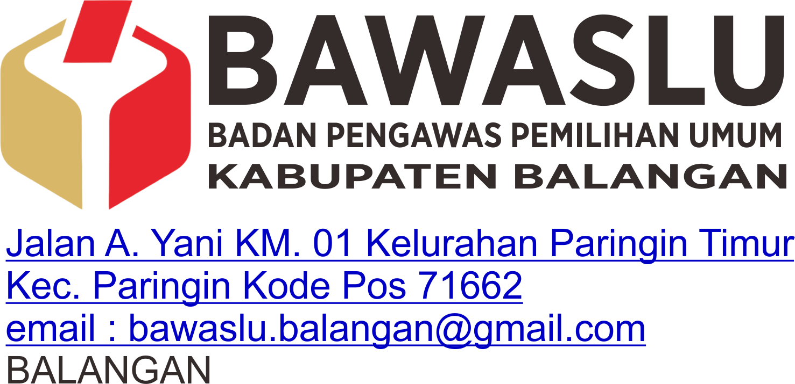

**FORMULIR PERMOHONAN INFORMASI  
No. Pendaftaran: ……../Bawaslu-KS-01/IP/2022**

|  |  |  |  |  |  |  |
| --- | --- | --- | --- | --- | --- | --- |
| **Nama** | : | Hatta Mu’min | | | | |
| **Alamat** | : | Jln. Datuk Kandang Haji Rt. 01 No. 046 Desa Baruh Panyambaran Kec. Halong Kab. Balangan | | | | |
| **Pekerjaan** | : | Mahasiswa | | | | |
| **Nomor Telpon** | : | 081350203449 | | **Email** | : | Hattamumin23@gmail.com |
| **Rincian Informasi** | : | Meminta struktur Bawaslu Kabupaten Balangan | | | | |
| **Yang dibutuhkan** |  | Gambar Strukur Organisasi | | | | |
| Tambahan Kertas Jika Perlu |  |  | | | | |
|  |  |  | | | | |
|  |  |  | | | | |
| **Tujuan Memperoleh** | : | Untuk keperluan laporan praktek kerja lapangan ( PKL ) | | | | |
| **Informasi** |  |  | | | | |
|  |  |  | | | | |
| **Cara memperoleh** | 1 |  | Melihat/Membaca/Mendengarkan/Mencatat | | | |
| **Informasi\*\*** | 2 |  | Mendapatkan salinan Informasi (*Hardcopy*/ *Softcopy*)*** | | | |
|  |  |  |  | | | |
|  |  |  | | | | |
| **Cara mendapatkan** | 1 |  | Mengambil Langsung | | | |
| **Salinan Informasi** | 2 |  | Kurir | | | |
|  | 3 |  | Pos | | | |
|  | 4 |  | WhatsApp | | | |
|  | 5 |  | Email | | | |
|  |  |  | | | | |

Balangan, 21 Januari 2022

|  |  |
| --- | --- |
| **Petugas Pelayanan Informasi** | **Pemohon Informasi;** |
| **(Penerima Permohonan);** |  |
| (ARIF IKHWANI) | (HATTA MU’MIN) |
|  |  |